Different fields

Different types of magnets have different magnetic fields.
All magnets have a north-seeking-pole and a south-seeking-pole.
The poles of a magnet are not always at each end.

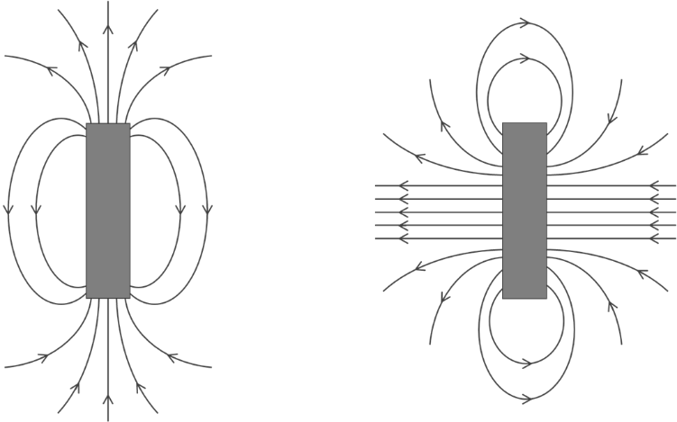

To do: Connect each magnet to all of the facts that describe it.
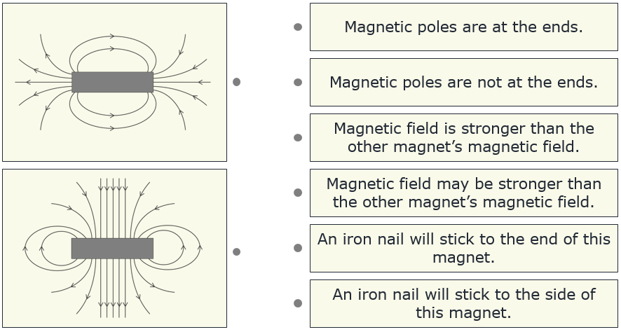

Physics > Big idea PEM: Electricity and magnetism > Topic PEM3: Magnets and electromagnets > Key concept PEM3.1: Magnetic fields
Diagnostic question
Different fields

Overview
Learning focus: | The magnetic field around a magnet can be represented by field lines, which indicate the size and direction of the force of the magnet on the north-seeking-pole of another magnet.
Observable learning outcome: | Compare the magnetic fields of different magnets, in order to predict the properties of the magnets.
Question type: | Linking ideas
Key words: | Magnetic field, magnetic field lines, attract, repel

What does the research say?
There has been little research on students’ abilities to plot or interpret patterns of magnetic field lines around bar magnets. Often magnetic field patterns are presented as lines of force and shown as arrows pointing away from the north-seeking-pole and towards the south-seeking-pole. The force of the magnet on a magnetic object is described as bigger where the lines are closer together. This description is confusing in several ways and needs unpicking carefully with students. More accurately, magnetic field lines show the direction in which the north-seeking-pole of a magnet would be pushed or pulled.
When interpreting magnetic fields, the idea that the field is stronger where the field lines are closer together makes no sense to many students. The way students typically plot magnetic fields, with small ‘plotting’ compasses, allows them to add extra field lines at any point in a magnetic field pattern to make the field lines closer together at this point. This suggests that adding field lines makes the magnet stronger! The new field line however, will be closer to adjacent field lines at some points and further away from them at other points. Without accurate measurement of magnetic field strengths, magnetic field patterns can only give an indication of the relative strengths of different points in a magnetic field and the strengths of two different magnetic fields cannot be compared.
Ways to use this question
This task is intended for discussion in pairs or small groups. It is best done as a pencil and paper exercise.
Students should read the statements and follow the instructions on the worksheet. Listening in to the conversations of each group will often give you insights into how your students are thinking. Each member of a group should be able to report back to the class.
Feedback from each group can be used, with careful teacher questioning, to bring out a clear description or explanation of the science.

Differentiation
The quality of the discussions can be improved with a careful selection of groups; or by allocating specific roles to students in the each group. For example, you may choose to select a student with strong prior knowledge as the scribe, and forbid them from contributing any of their own answers. They may question the others and only write down what they have been told. This strategy encourages contributions from more members of each group.
NB in any class, small group discussions typically improve over time and a persistence with this strategy is often very successful in the medium to long term.
Expected answers
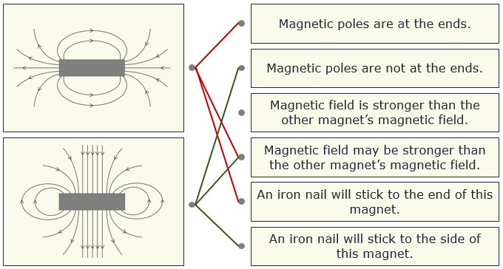
How to respond - what next?
Magnetic objects, like an iron nail will be pulled along magnetic field lines towards a magnet, no matter which direction the arrows on the field lines are pointing.
The poles of a magnet are found where the magnetic field lines intersect with the magnet.
The field lines in the second magnet are closer together than the first magnet, and stay closer together further from the magnet. This does not however, show that the second magnet is stronger. It may be just that more magnetic field lines have been drawn on the second diagram. To find out which magnet is strongest would require some form of measurement or test.
If students have misunderstandings about what the magnetic fields of different magnets predict about the properties of the magnets, it can help to give students the opportunity to plot the magnetic fields of different types of magnets, to predict the properties of each magnet and then to test them out. These could include horseshoe magnets, the magnets from electric motor kits, or the disc magnets found on the back of ‘fridge magnets’. (Some of these magnets will need to be placed on their side, in order to obtain a clear magnetic field pattern.) Students could also be given the opportunity to compare the strength of the different magnets, which they have drawn magnetic field patterns for.
The following BEST ‘response activities’ could be also used in follow-up to this diagnostic question:
- Response activity: Plotting magnetic fields
- Response activity: Earth magnet
Acknowledgments
Developed by Peter Fairhurst (UYSEG).
Images: Peter Fairhurst (UYSEG).

